COMMS PLAN | Photographing the medals for the Flagship Valor livery

JETNET

As we close out Military Appreciation Month, here’s a behind-the-scenes look at one of the ways American honors our veterans and those who are still serving in the military.

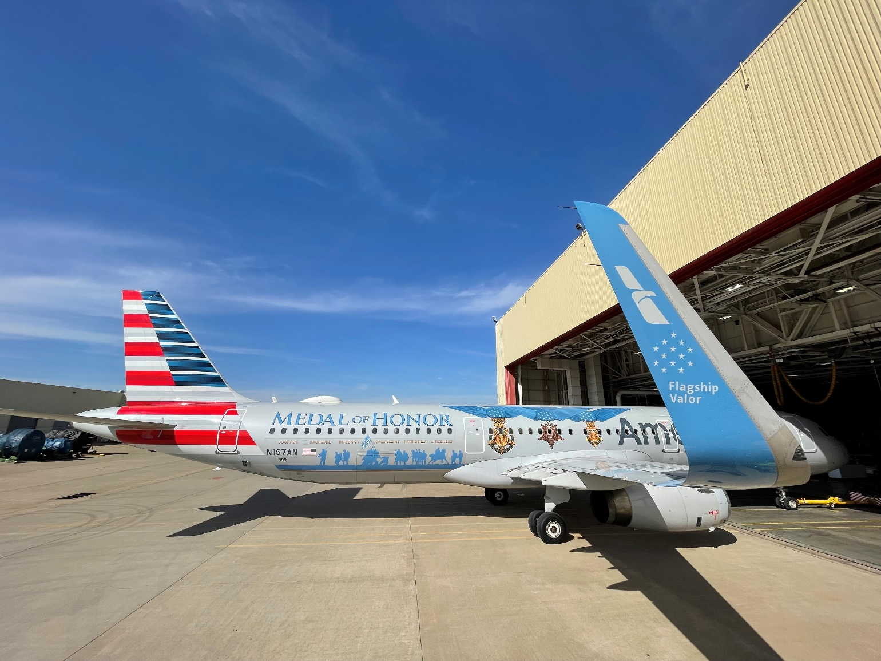

Operation capture Medal of Honor assets
Flagship Valor was unveiled March 25, 2022, to coincide with the groundbreaking of the National Medal of Honor Museum in Arlington, Texas. Most of the time, Flagship Valor is in regularly scheduled service, but it’s also used for special Military and Veterans Initiatives (MVI) missions, and it’s highly requested for Honor Flights at hubs around the country.

“This special livery is an extension of our support to great organizations like the Medal of Honor Foundation, the Woody Williams Foundation and the National Medal of Honor Museum that recently opened, among many others,” explained Randy Stillinger, Manager of Military and Veterans Initiatives at American. “American has a long history of supporting those who serve in the military, and Flagship Valor recognizes the sacrifices that they’ve made.”
However, creating the Flagship Valor livery was an ambitious task.
Early in the design process in April 2021, it became clear the centerpiece of the Flagship Valor livery would be the Medals of Honor. Randy and Van Urfalian, Creative Director at TNYCP Creative, quickly reached out to the Congressional Medal of Honor Society for photos of the medals, but the resolution wasn’t high enough for large-scale printing.
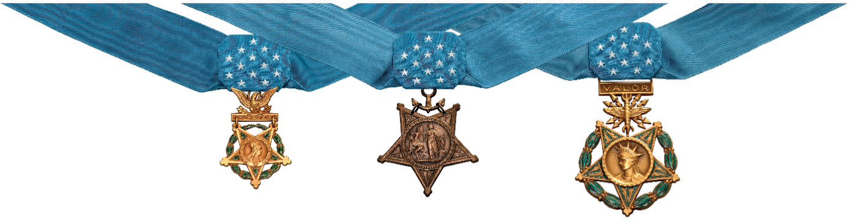
Photo caption: There are three types of Medals of Honor in the United States: the Army Medal of Honor (left), the Navy Medal of Honor (middle), which is also awarded to Marines and Coast Guard members, and the Air Force Medal of Honor (right). (Photo courtesy of Van Urfalian, Creative Director, TNYCP Creative.)
To do the medals justice, they needed to be professionally photographed in incredibly fine detail. The team packed their gear and traveled to Patriots Point, Mount Pleasant, S.C. They were surprised to find themselves walking up the gangway to the U.S.S. Yorktown, the decommissioned aircraft carrier turned museum. The medals were stored aboard the massive ship where the Congressional Medal of Honor Society also has an office.
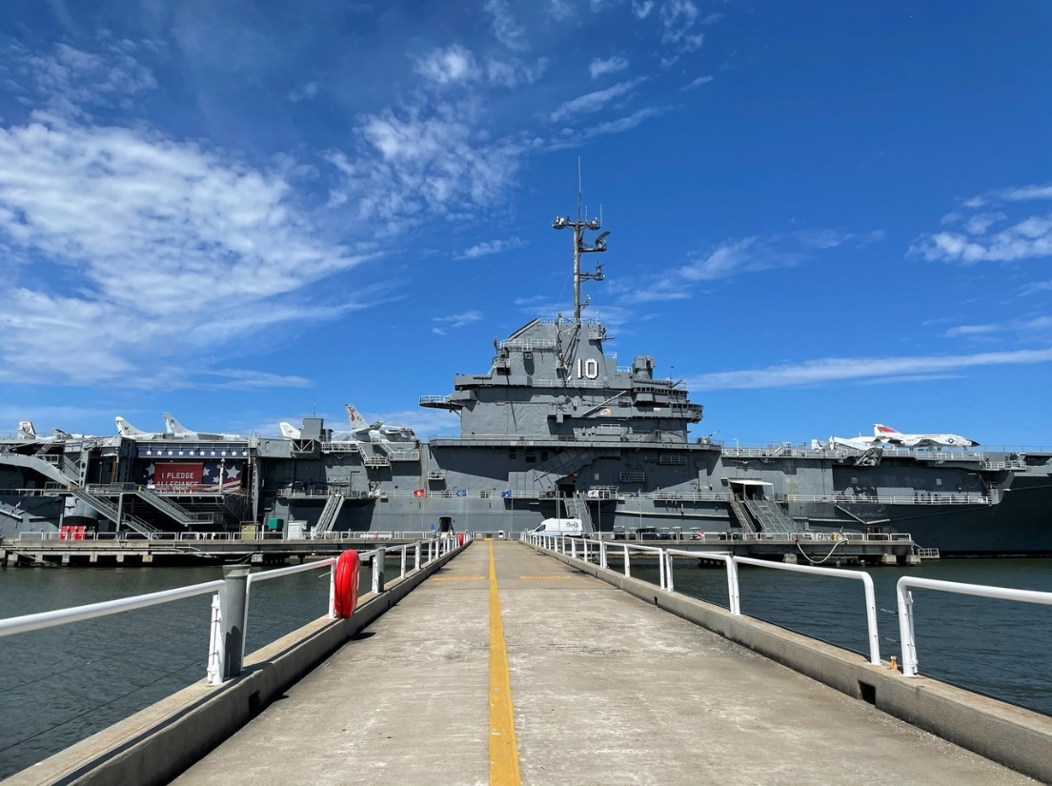
Picture caption: The U.S.S. Yorktown, the decommissioned aircraft carrier turned museum, located in Patriots Point, Mount Pleasant, S.C. (Photo courtesy of Van Urfalian, Creative Director, TNYCP Creative.)
Before the trip, Roger Steele, Base Maintenance Supervisor at Tech Ops – Tulsa, provided a crucial piece of the puzzle: a section of aircraft paneling painted Silver Eagle gray. It was the same surface the final images would be applied to, ensuring the photographs would look as real as possible. One by one, the three distinct medals were photographed in high definition. Each shot was painstakingly arranged, capturing the weight of history in every frame.

Photo caption: Inside the decommissioned aircraft carrier, Van Urfalian captures every detail on all three Medals of Honor. Photo courtesy of Van Urfalian, Creative Director, TNYCP Creative.
When the final images were applied to the aircraft and Flagship Valor made its debut 18 months later on March 25, 2022, there was no mistaking it: the medals looked true to life, down to every last detail.
In addition to the pristine images of the three Medals of Honor, the aircraft also spells out the six characteristics that embody the Medal of Honor and those who have received it. Below that are a series of blue silhouettes that depict the seven major military conflicts since Abraham Lincoln created the medal in 1861 — from the Civil War to the Global War on Terrorism. This part of the livery pays tribute to all who have served, not just those who wear the medal.
“We tried hard to keep this project a secret, even to the extent that we flew it home under the cover of darkness and snuck it into Hangar 5 at DFW the night before the dedication,” Randy said. “With all the aircraft spotters around the system, we had some people wondering and speculating on social media, but we were able to keep the unveiling a surprise.”

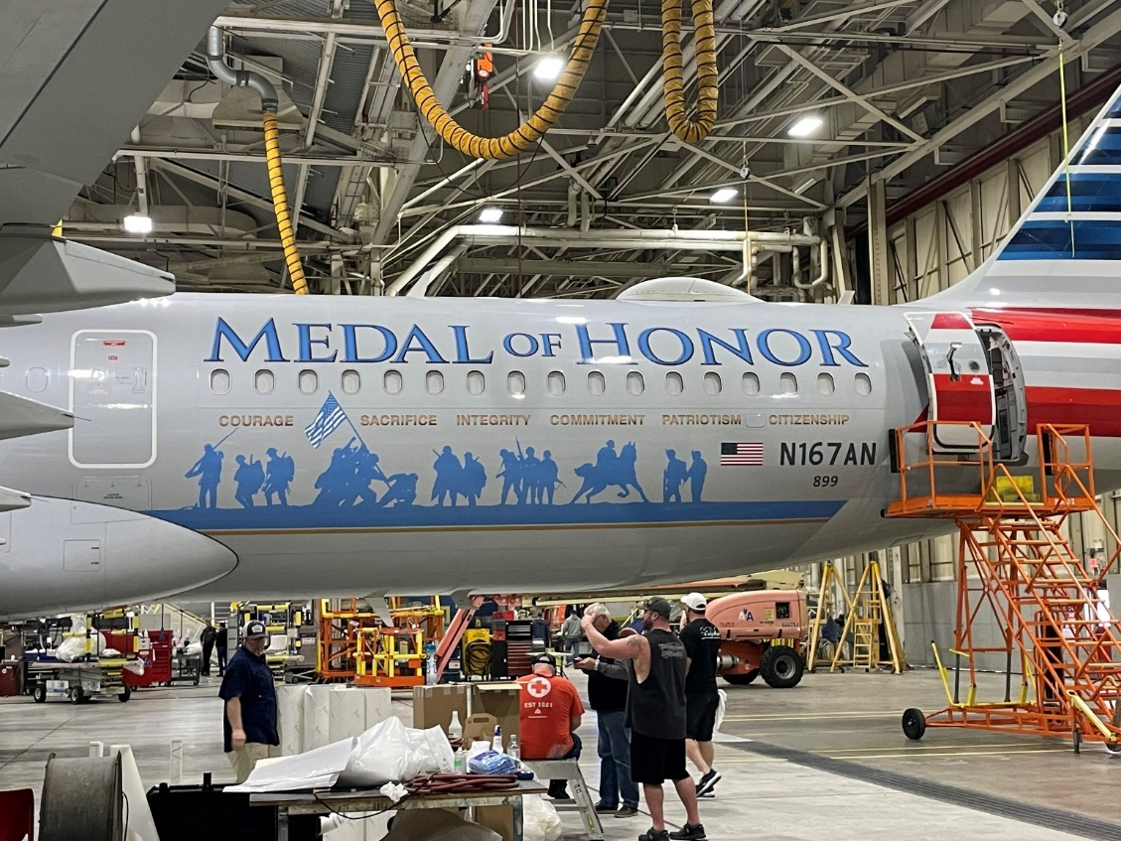
Picture caption: The Flagship Valor livery is a combination of paint and custom wrap. It features 13 stars, symbolizing the original 13 colonies of the United States, and the light blue color throughout the design is the symbolic color for valor.

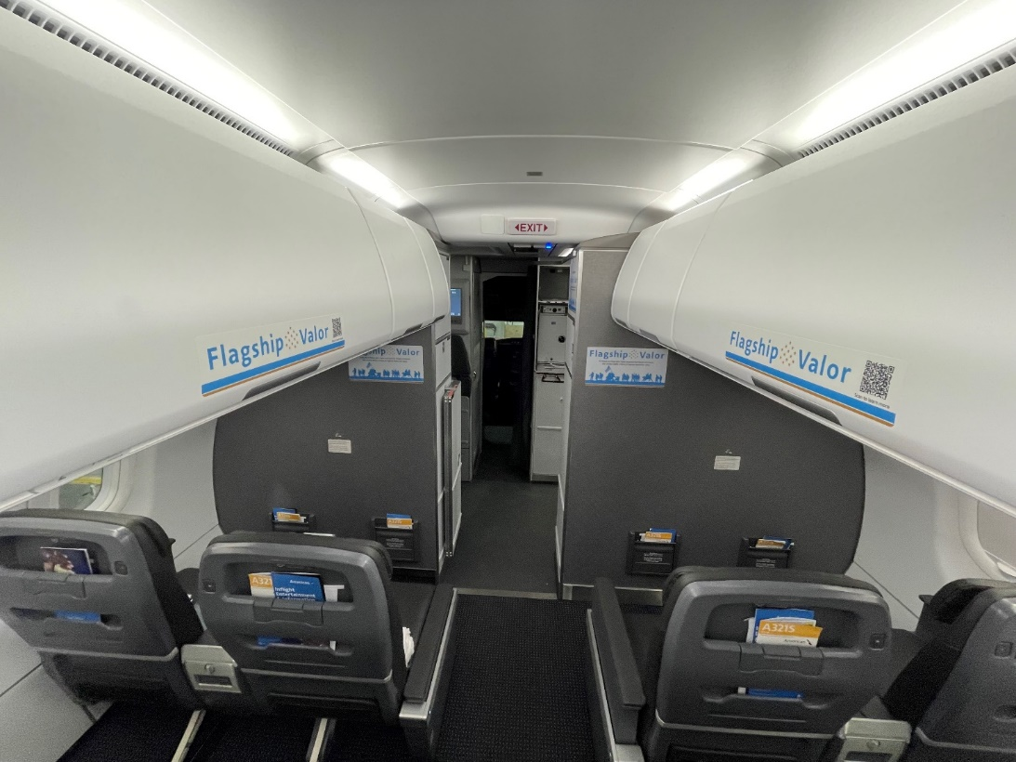
Picture caption: Interior signage and QR codes were installed on the overhead bins to give our passengers an opportunity to learn more about the Medal of Honor and our support for the recipients.

# # #

